
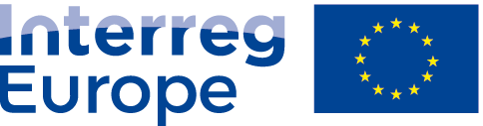
Sharing solutions for better regional policies
European Union | European Regional Development Fund

ANNEX IV of the SWARE Partnership Agreement
Preparation cost division

Partner name | ERDF amount | Total amount
LP – Vereniging Regio Water | 11 458,12 EUR | 13 480,14 EUR
PP2 – Tipperary County Council | 698,67 EUR | 821,97 EUR
PP3 – Metropolitan City of Milan | - | -
PP4 – Pons Danubii EGTC | 593,21 EUR | 697,89 EUR
PP5 – Vidzeme Planning Region | - | -
PP6 – Province of South Holland | - | -
TOTAL | 12 750 EUR | 15 000 EUR

