

Sharing solutions for better regional policies

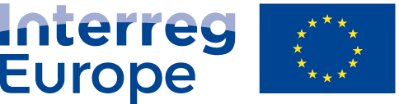

European Union | European Regional Development Fund

**ANNEX IV of the SWARE Partnership Agreement**

**Preparation cost division**

|  |  |  |
| --- | --- | --- |
| Partner name | ERDF amount | **Total amount** |
| LP – Vereniging Regio Water | 11 458,12 EUR | **13 480,14 EUR** |
| PP2 – Tipperary County Council | 698,67 EUR | **821,97 EUR** |
| PP3 – Metropolitan City of Milan | - | **-** |
| PP4 – Pons Danubii EGTC | 593,21 EUR | **697,89 EUR** |
| PP5 – Vidzeme Planning Region | - | **-** |
| PP6 – Province of South Holland | - | **-** |
| **TOTAL** | **12 750 EUR** | **15 000 EUR** |